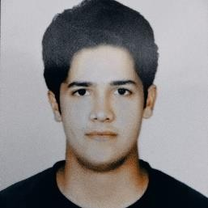

muhammadarbazkhan2@gmail.co m
Arbaz Khan
Data Engineer
As a Data Engineer, I specialize in designing, building, and maintaining scalable data
pipelines and infrastructure. With expertise in data modeling, data Analytic, ETL
processes, and database management.

03020473547
Lahore, Pakistan

SKILLS
Python JAVA
SQL SQA
Angular
C#
Data analytics

LANGUAGES
English
Professional Working Proficiency

Urdu
Native or Bilingual Proficiency

INTERESTS
Coding movies
Badminton
tennis
EDUCATION

BS Information Technology

University Of Education
08/2019 - 07/2023,

INTERMEDIATE

Punjab Group Of Colleges
05/2017 - 05/2019,
Courses
Pre-Engineering

MATRICULATION

Society Public School, Lahore
04/2005 - 04/2017,
Courses
Science

WORK EXPERIENCE

Mind Bridge
10/2022 - 03/2023,
Lahore

Cinergie Digital
11/2023 - currently working,
Lahore

PROJECTS

Deployed Single Store Cluster and Tibco Spotfire server at SSGC establishing
a robust data infrastructure for the organization.

Integrated data across diverse databases, enhancing overall data consistency
and enabling seamless information flow within the organization.

Developed an ETL routine to transfer data from Oracle to Single Store,
streamlining data integration processes

Leveraged proficiency in IBM COGNOS ANALYTICS and Tibco Spotfire to
skillfully analyze in

